MS Office Mac Installation and Activation

Step 1: Sign in and install Office
- Sign in with your work or school account at https://portal.office.com/OLS/MySoftware.aspx.
- On the Office page page, under Install Office 2016 for Mac, select Install to begin downloading the installer package.
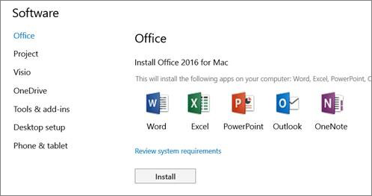
- Once the download has completed, open Finder, go to Downloads, and double-click Microsoft_Office_2016_Installer.pkg. (The name might vary slightly.)
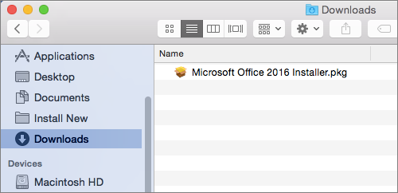
Tip: If you see an error that says the Microsoft_Office_2016_Installer.pkg can't be opened because it is from an unidentified developer, wait 10 seconds and then try double-clicking the installer package again. If you're stuck at the Verifying…. progress bar, close or cancel the progress bar and try again.
- On the first installation screen, select Continue to begin the installation process.
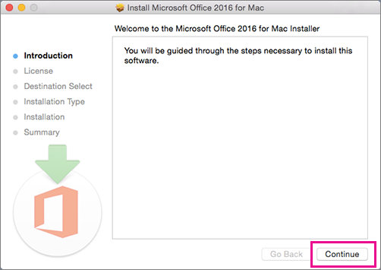
- Review the software license agreement, and then click Continue.
- Select Agree to agree to the terms of the software license agreement.
- Review the disk space requirements, and then click Install.
- Enter your Mac login password, if prompted, and then click Install Software. (This is the password that you use to log in to your Mac.)
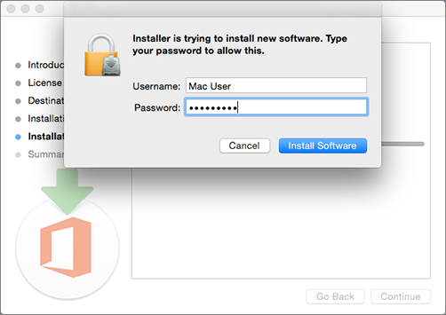
- The software begins to install. Click Close when the installation is finished. If Office installation fails, see What to try if you can't install or activate Office 2016 for Mac using Office 365 for business.
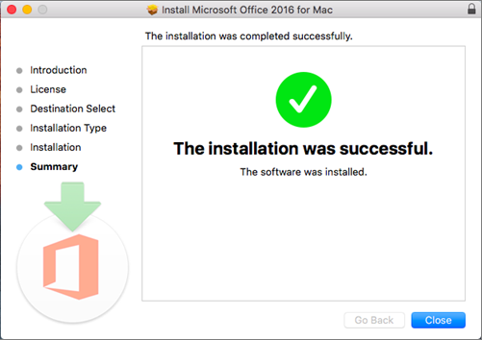
Tip: Were these steps helpful? Please leave us a comment!

Step 2: Launch an Office for Mac app and start the activation process
- Click the Launchpad icon in the Dock to display all of your apps.

- Click the Microsoft Word icon in the Launchpad.
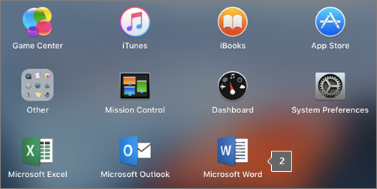
- The What's New window opens automatically when you launch Word. Click Get Started to start activating. If you need help activating Office, see Activate Office 2016 for Mac. If Office activation fails, see What to try if you can't install or activate Office 2016 for Mac using Office 365 for business.
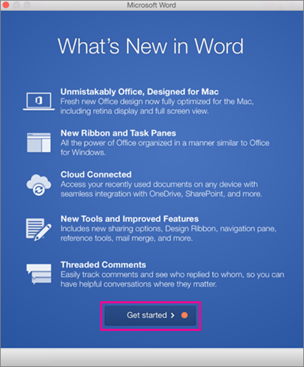

Installation notes
Keep in mind:
- You may need to check in with your organization's technical support team before installing apps.
- If you're not sure you have a license to install Office 2016 for Mac, see What Office 365 business product or license do I have?

Link:-- https://support.office.com/client/Download-and-install-or-reinstall-Office-365-Office-2016-or-Office-2013-on-your-PC-or-Mac-4414eaaf-0478-48be-9c42-23adc4716658

*******************************************************88

https://www.microsoft.com/en-gb/software-download/office

